Test Case: tc002_SPX_Dev5_Crear_Requisicion_Spot_Tipo_Cobro_Project
Step 1 - Enter username and password and click to button Enter: Credentials Entered
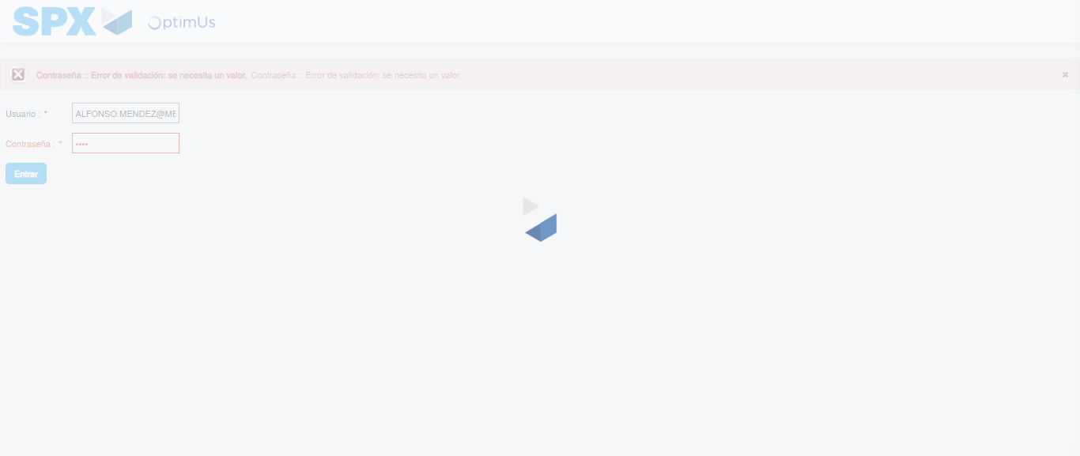Image file-name: QC_Testing-tc002_SPX_Dev5_Crear_Requisicion_Spot_Tipo_Cobro_Project-1784307726127

Step 2 - Select to UEN and Access to Spot Buy Requisitions : UEN Correctly selected and Correct access
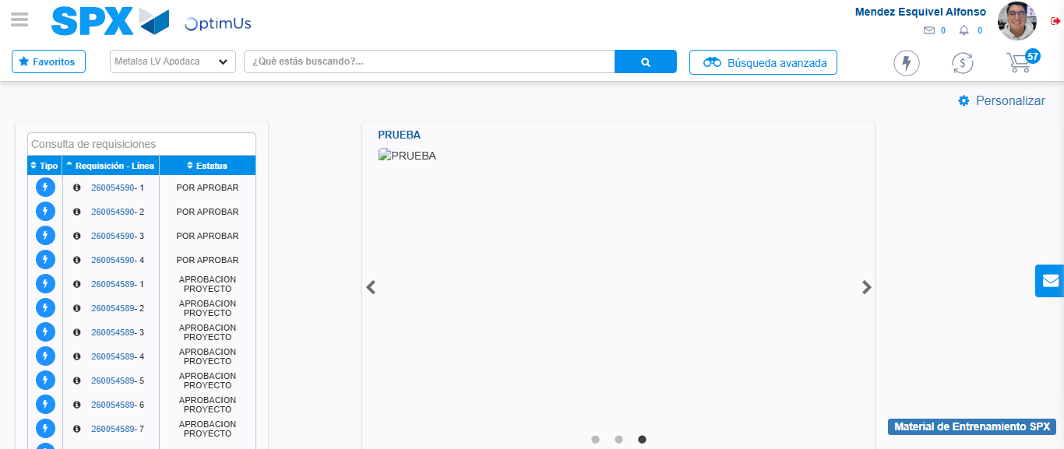Image file-name: QC_Testing-tc002_SPX_Dev5_Crear_Requisicion_Spot_Tipo_Cobro_Project-1784307773243

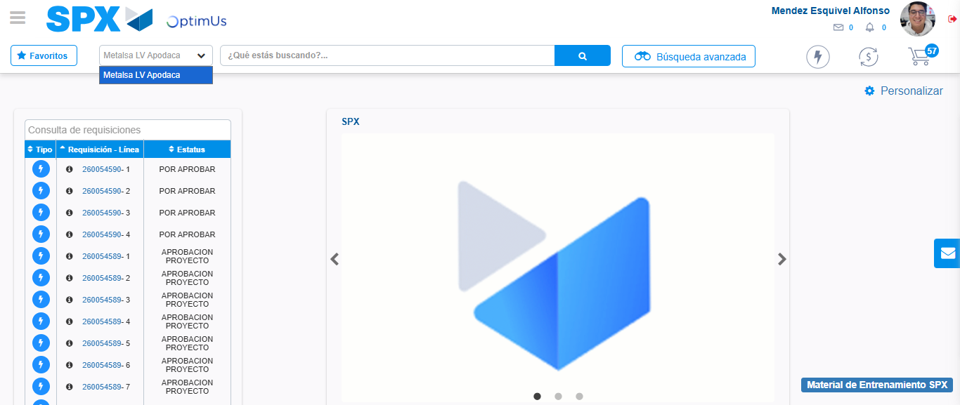Image file-name: QC_Testing-tc002_SPX_Dev5_Crear_Requisicion_Spot_Tipo_Cobro_Project-1784307775792

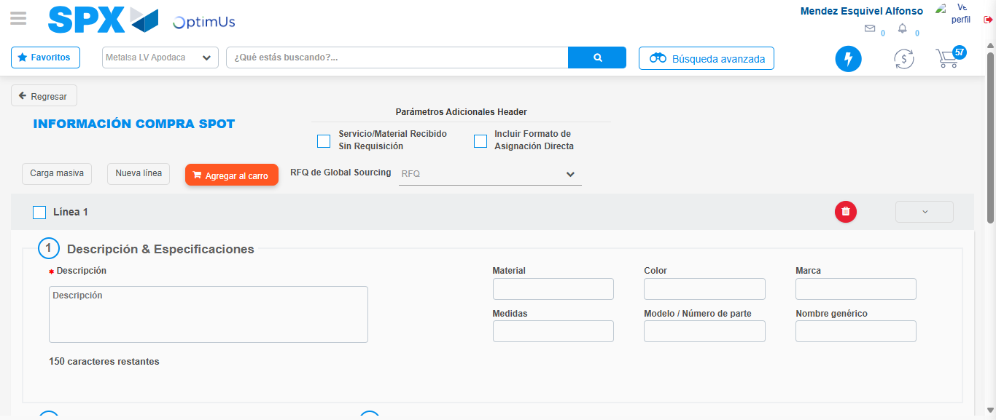Image file-name: QC_Testing-tc002_SPX_Dev5_Crear_Requisicion_Spot_Tipo_Cobro_Project-1784307845592

Step 3 - Data Capture Spot Buy Requisition: Data captured correctly
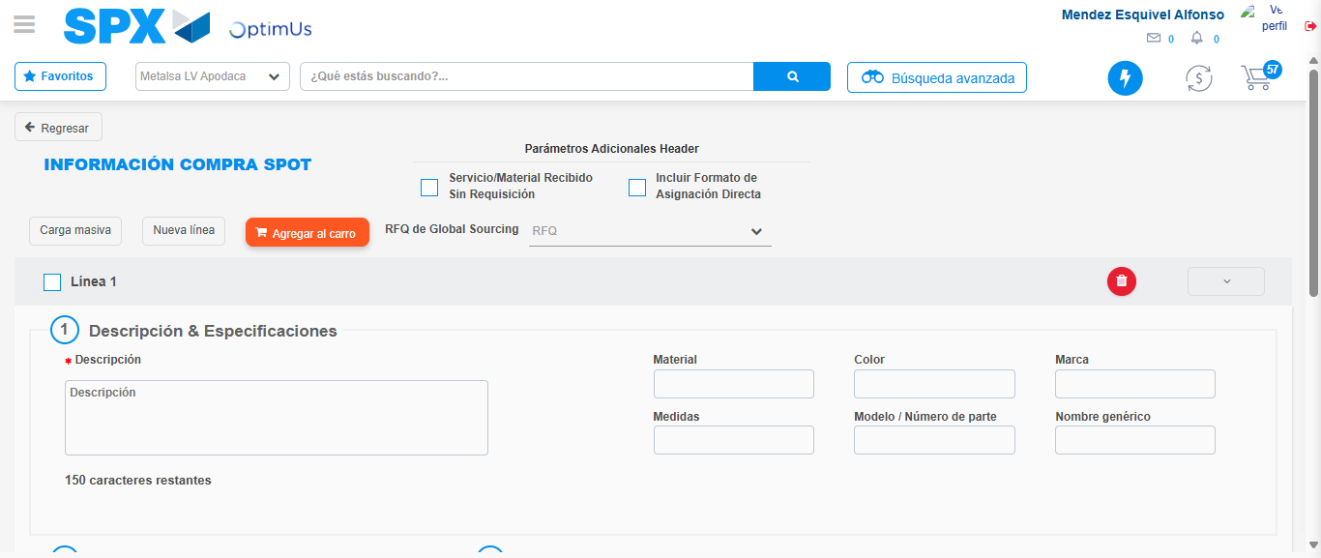Image file-name: QC_Testing-tc002_SPX_Dev5_Crear_Requisicion_Spot_Tipo_Cobro_Project-1784307845871

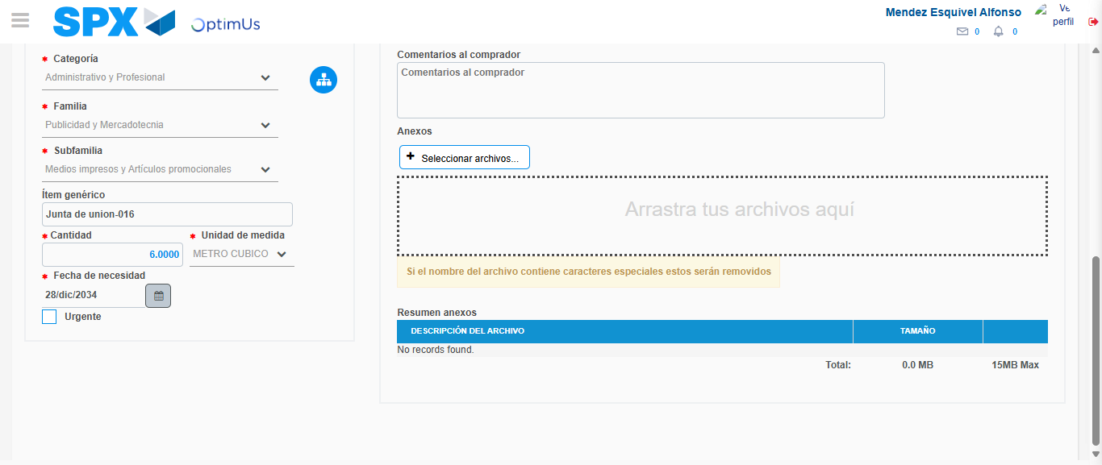Image file-name: QC_Testing-tc002_SPX_Dev5_Crear_Requisicion_Spot_Tipo_Cobro_Project-1784307857394

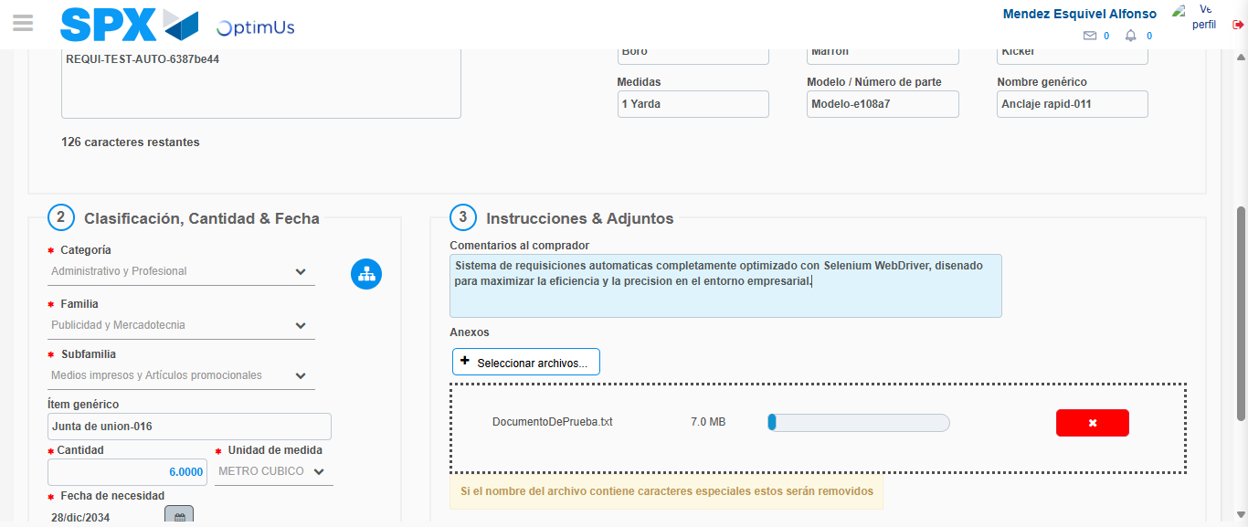Image file-name: QC_Testing-tc002_SPX_Dev5_Crear_Requisicion_Spot_Tipo_Cobro_Project-1784307858166

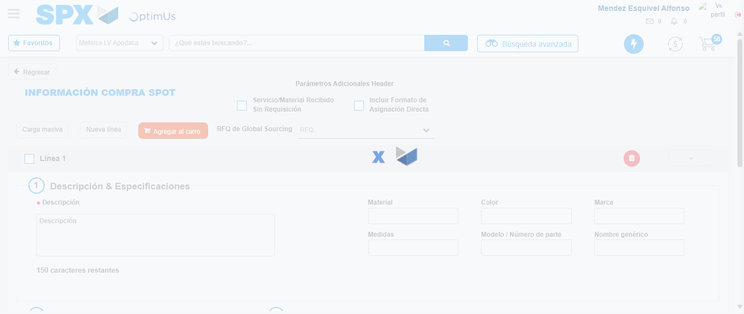Image file-name: QC_Testing-tc002_SPX_Dev5_Crear_Requisicion_Spot_Tipo_Cobro_Project-1784307864014

Step 7 - Return to Main Page SPX : Return to Main Page SPX
Image file-name: QC_Testing-tc002_SPX_Dev5_Crear_Requisicion_Spot_Tipo_Cobro_Project-1784307773243

Image file-name: QC_Testing-tc002_SPX_Dev5_Crear_Requisicion_Spot_Tipo_Cobro_Project-1784307775792

Image file-name: QC_Testing-tc002_SPX_Dev5_Crear_Requisicion_Spot_Tipo_Cobro_Project-1784307845592

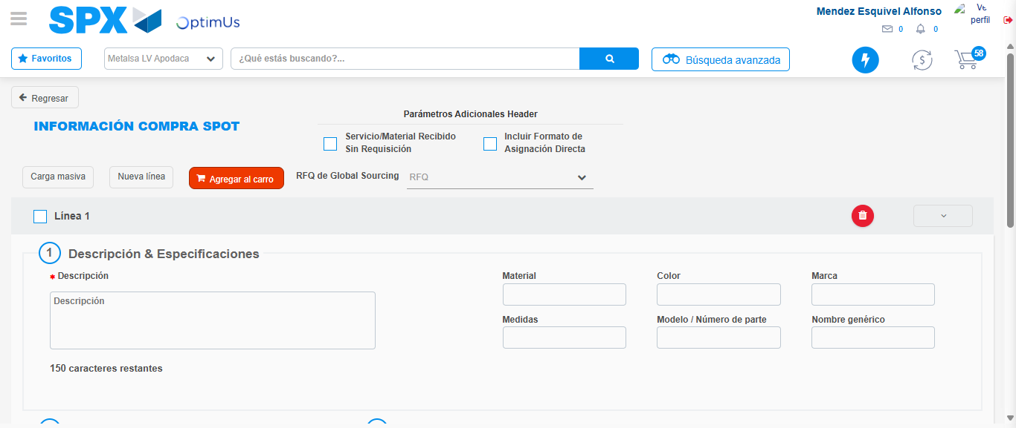Image file-name: QC_Testing-tc002_SPX_Dev5_Crear_Requisicion_Spot_Tipo_Cobro_Project-1784307866235

Image file-name: QC_Testing-tc002_SPX_Dev5_Crear_Requisicion_Spot_Tipo_Cobro_Project-1784307866403

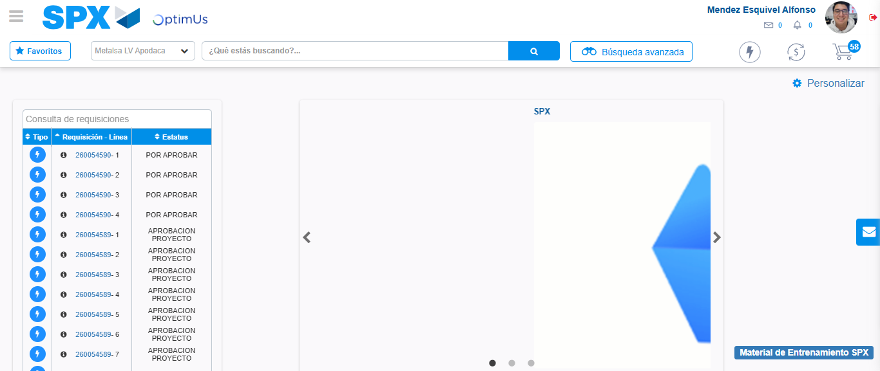Image file-name: QC_Testing-tc002_SPX_Dev5_Crear_Requisicion_Spot_Tipo_Cobro_Project-1784307887424

Step 8 - Log Out : Log Out SPX
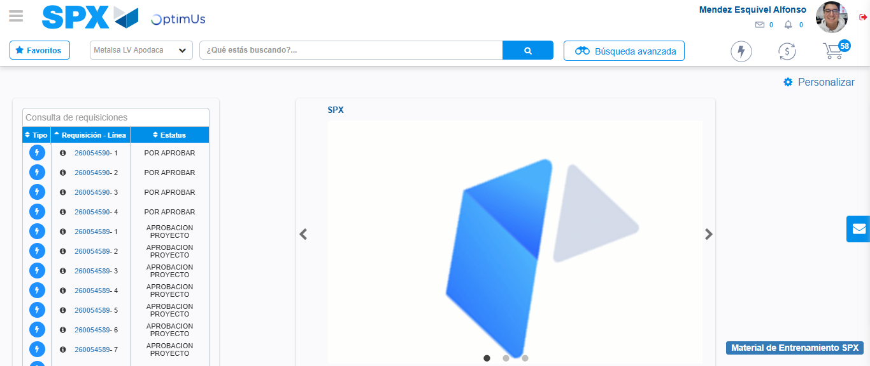Image file-name: QC_Testing-tc002_SPX_Dev5_Crear_Requisicion_Spot_Tipo_Cobro_Project-1784307887683

